
MATHEMATICS

YEAR 8 EXAMINATION

SEMESTER ONE 2017
Allowed time: 50mins
Name: _______________________________________

Teacher: _______________________________________ /60

Class: ___________________ /60

1. Use recurring decimal notation to write these (2 Marks)

a) 0.085418541.. =

b) 0.9999999… =

2. Convert the following to improper fractions. (2 Marks)

$a). 2\frac{3}{4}$ =

b. $6\frac{7}{8}$=

3. Convert the following to mixed numerals. (2 Marks)

$a. \frac{15}{7}$ =

b. $\frac{43}{6}=$

4. Use index laws to solve the following (4 marks)

- 10^{9 ÷} 10² =

- a⁶ x a² =

- 5 x 3⁰ =

- (3³)⁶ =

5. Place the following in the correct order Smallest to largest (4 marks)
a. 31%, $\frac{3}{10}$ , 0.301, -33%, $\frac{2}{8}$

b) $\frac{50}{200}$ , 0.03, 130%, 1.27, $\frac{5}{3}$


6. Convert each of the following into fractions. (6 Marks)
Fraction | Decimal | Percentage
 | 1.45
$$\frac{3}{4}$$
 |  | 120%
$$\frac{2}{5}$$
 | 0.08
 |  | 31%

6. Simplify the following expressions (4 marks)

- $2x+5x + 4x$

- $\frac{9ab}{3b}$

- $2g × 6h$

- $9w-4w^{2}-6w^{2}-2w$

7. Expand the following expressions (2 marks)

- $3(4x +9) =$

- $7p\left(5x-3y\right)+2(4px+8py)$ =

8. Factorise the following expressions (2 marks)

- $5x + 25 =$

- $3kjg +12kmg =$

- Write these as an exact decimal. If that’s not possible write ‘irrational’ (3 marks)
66.6%
$$\sqrt{9}$$
π
0.0898989…
$$\sqrt{10}$$
$$\frac{1}{9}$$

- Place the following words/ phases correctly on the probability scale. (2 marks)
Buckley’s chance, possible, maybe, likely, Unlikely, 90%
Impossible Certain

11. Explain the difference between Theoretical and Experimental Probability? (2 marks)

13. A bag has variety of different coloured balls in it. These include 8 blue, 3 green, 4 red, 6 yellow and 2 brown. What is the probability of pulling out the following? (5 marks)

What is the Sample Space?

Blue? Red, yellow and brown?

Not green? A ball?

14. For each set of three triangles below, determine which of the three triangles are congruent, state which rule proves they are congruent and write a statement of congruence. (3 marks)
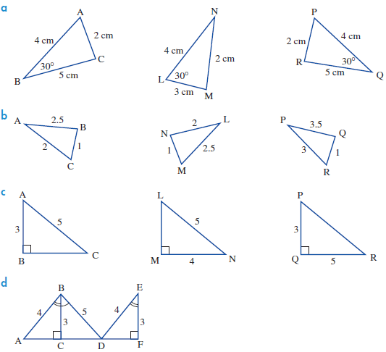___________________________________________________________________________________________________________________________________________________________________________________________________________________________________________________________________________________________________________________________________________________________________________________________________________________________________________________

- Given that each set of triangles below are congruent to each other.
Find the missing values. (5 marks)
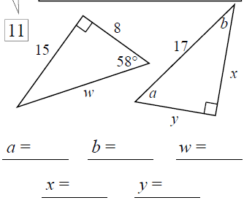

- Prove that the pair of triangles below is congruent and hence find the value of the value marked with an x. (4 marks)

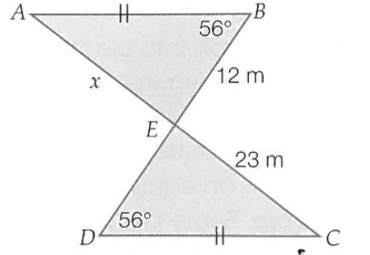

- Determine the size of the angle marked (5 marks

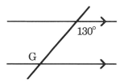
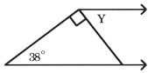

G=

Y =

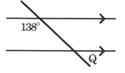
Q =

- Evaluate the following (3 marks)

- $20 + -5=$
- $-4 + -7=$
- $-3 - - 5=$
- $-5 × -4 =$
- $-5 – 7=$
- $7 × -4=$

